Progress Report 3

Term 3 week 8

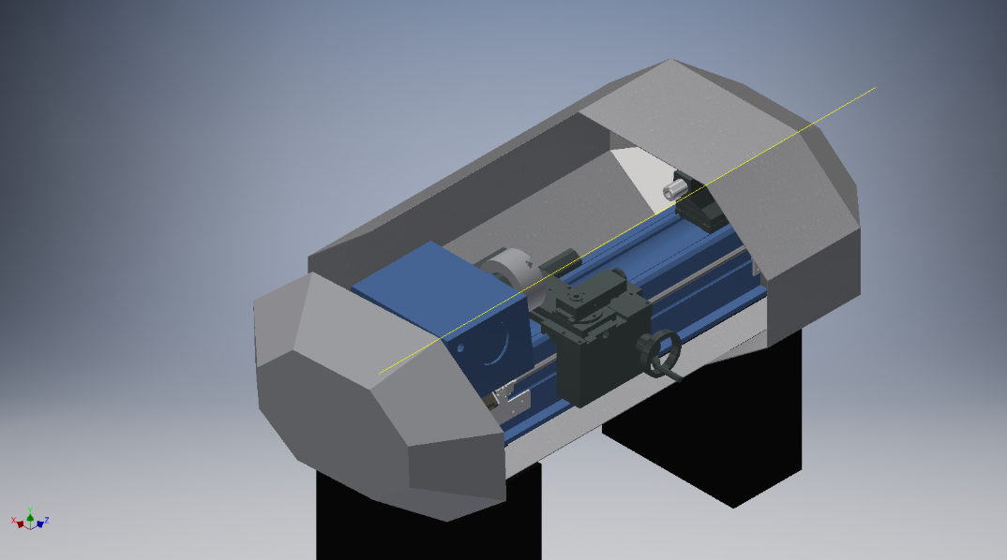Lathe cover parts inventor design started. So far we (with Corey Wise) have done two parts of the lathe cover. The shape and dimensions are pretty reasonable. There are more parts to be drawn but it will be done in a matter of time.

I also have started drawing an ideal door for the cover. Simple shape perfect for the main cover, the door handle is simple but can be change if needed to.

